Input Manager Script Support

**Request:** Have a look through the script and try to get the input to register with an xbox controller.

**Master of Task:** Samuel

**Support on Task:** Jonathan

Notes:

So, there was a few problems that seemed to hinder this script from working. These are listed below:

* Script been named “Input Manager”.
* Input Manager in unity have 2 axes named the same.
* Method of determining if an input is pressed

The name of the script had already been fixed, just not pushed so this wasn’t the problem that needed looking at. The script however seemed to no register inputs from the controller or was always showing as true.

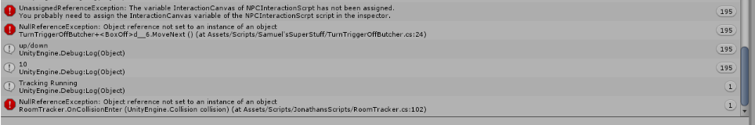

Changes were made to the input manager in unity to rename the axes for controllers to have the letter J after then to see if it made a difference, which it did.

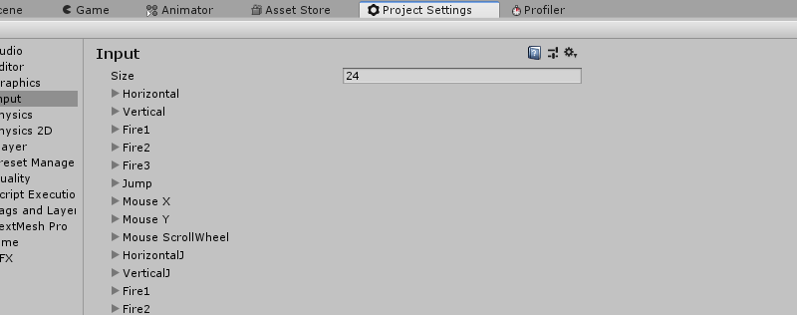The script was now registering input but not moving, though it seemed the script wasn’t finished to move the player as vector3 would always be 0,0,0.

This was tested by getting one of the other controller axes (axis 4) working with to rotate the player. This worked and proved that the script was working but just needed some more work.

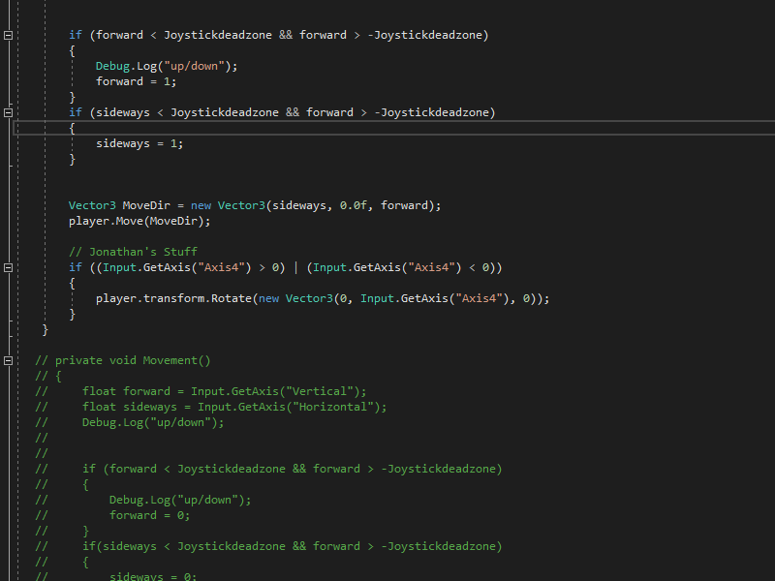

Conclusion

The script does work with the changes made, the input manager could use a clean up which will be a task for next sprint. To get the controller working the code added shows how to detect the axis which can be easily used to work with movement.